PirateBot Debug Howto

Prerequisites (Everything's free):

* Visual Studio
* [JetBrains dotPeek](https://www.jetbrains.com/decompiler/download/) v1.2 and up
* [Python 2.7](https://www.python.org/download/releases/2.7/)
* [Python Tools for Visual Studio](https://pytools.codeplex.com/)
* Configure Visual Studio:
  + Go to Tools->Options->Debugging->General:
    - Uncheck the "Enable Just My Code" option
    - Uncheck the "Enable .NET Framework source stepping" option
    - Check the "Enable source server support" option
    - Uncheck the "Require source files to exactly match the original version
  + Go to Tools->Options->Debugging->Symbols
    - Add [**http://localhost:33417/**](http://localhost:33417/)to the list

Howto:

* Go to **debug\** and open **PirateDebugProject.sln** in Visual Studio
* Make sure there's a breakpoint set at **engine.py** at the **run_game** method at **game.start_game()**.
* Right click on the project at the solution explorer window and go to **properties**.
  + Go to the debug tab and change the command line arguments if you need to
  + The two last arguments are the bots
  + Make sure that each path is surrounded by quotes (")
  + The paths are relative to the **starter_kit\lib** folder!
* Now you can run the python runner by clicking **Start** (usually F5 in Visual Studio)
  + The program will halt at the breakpoint
* Open up dotPeek and go to **Windows->Process** Explorer and choose **cshRunner.exe**
* The assembly list on the left will list on a few assemblies.
* Click on the **Start Symbol Server** at dotPeek. If asked, click on "**All assemblies**" at the dialog
* At the assembly list, right click on the one with the random-ish name (something made of couple of random letters and numbers) – that's our bot. Confirm it by checking if it includes the right classes (expand its entry at the assembly list).
* Right click on the entry of our bot and choose **Export to project** and then click **Export** at the dialog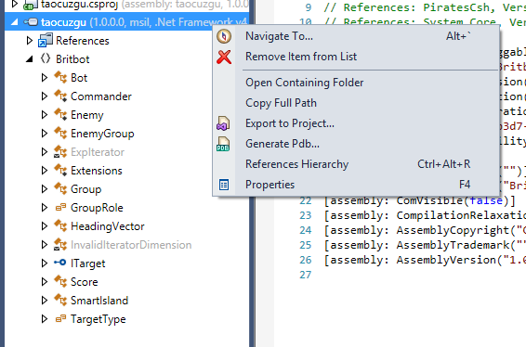
* Go to **debug\PiratesCsh\cshRunner** and then open up **cshRunner.sln** in Visual Studio (keep the Python program open! It should open another window of Visual Studio)
* Add the project you just exported to the solution via right-clicking on the solution and choose **Add->Existing Project** and then choose the exported project
* Visual Studio should open a windows saying it is loading symbols. Let it finish!
* Go to **Debug->Attach To Process** and choose **cshRunner.exe**
* Put a breakpoint at our **DoTurn** method
* Go to the other Visual Studio with the python program and hit **Continue** (usually F5 in Visual Studio)
* The Visual Studio with our bot should pop up and break our bot execution. Have fun!